Class test-1

Program 1: to check it is a perfect number or not.

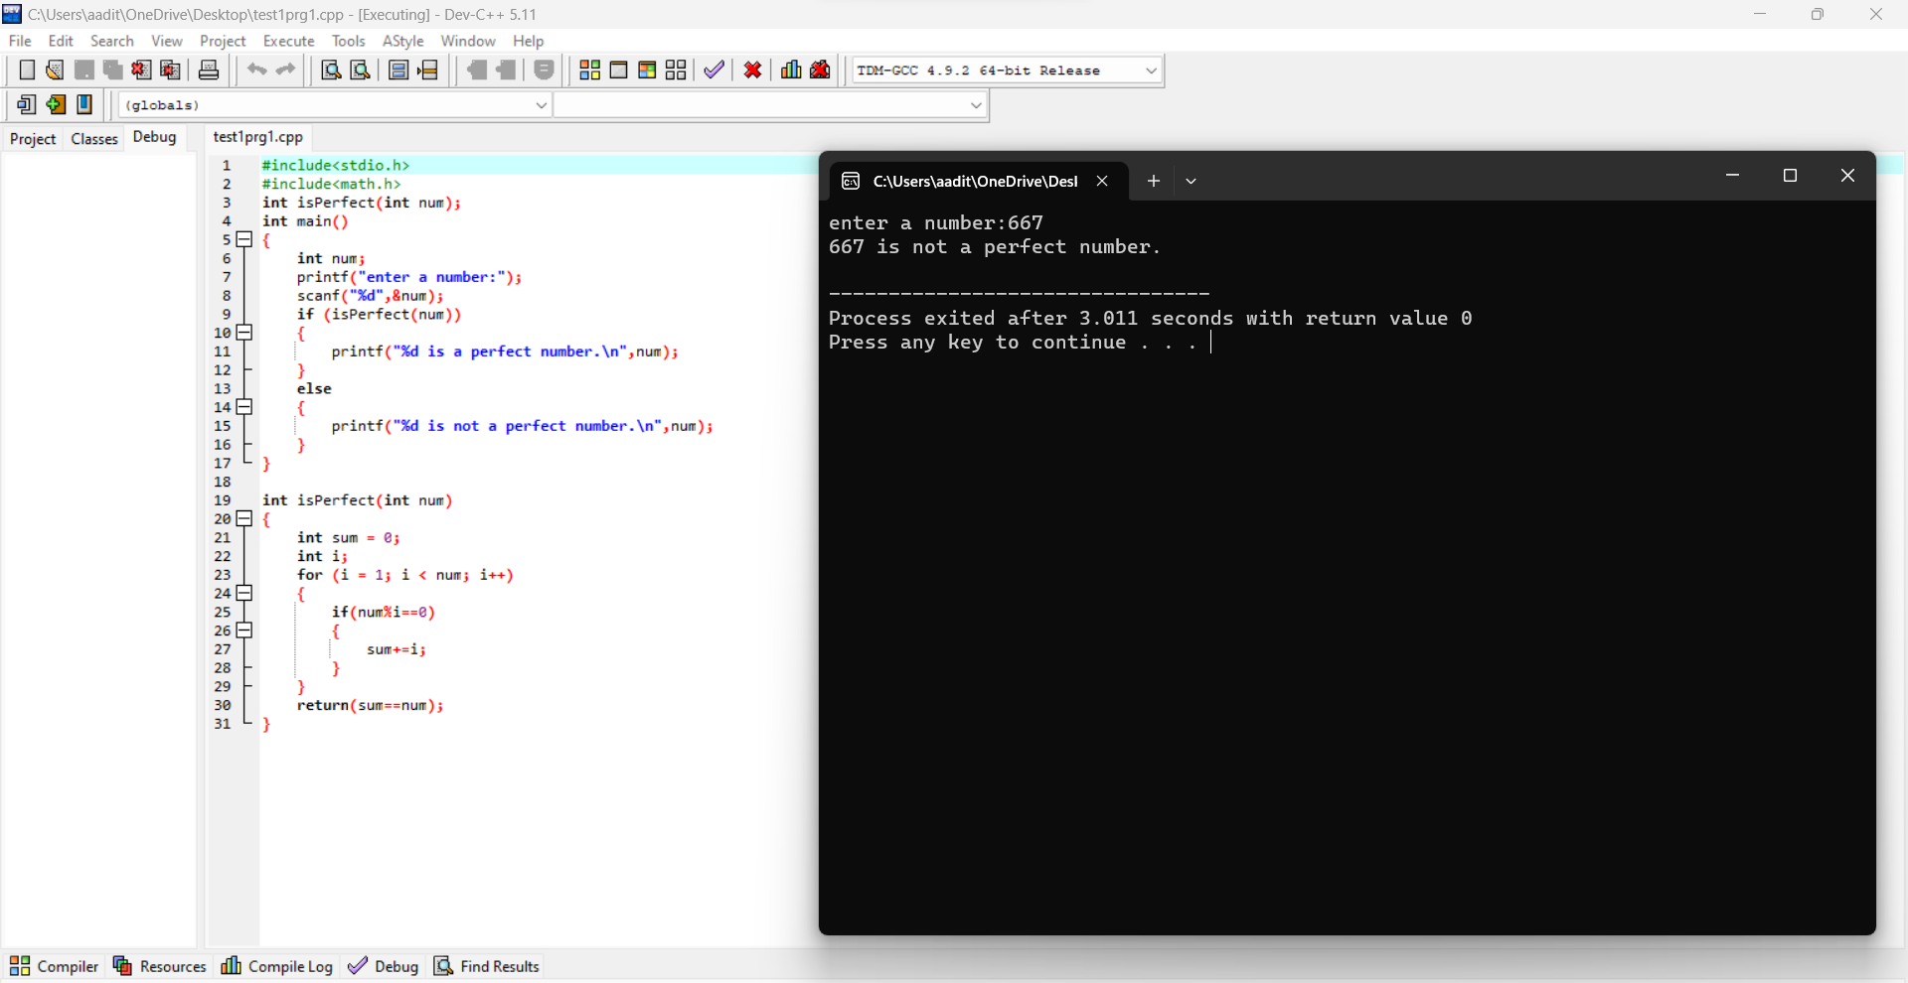

Program 2: to print the numbers divisible by 5.

